**Topic 6.2: Generalization of the N-Queens Problem**

**Question**  
Discuss the generalization of the N-Queens Problem to other board sizes and shapes, such as rectangular boards or boards with obstacles. Explain how the algorithm can be adapted to handle these variations and the additional constraints they introduce. Provide examples of solving generalized N-Queens Problems for different board configurations, such as an 8×10 board, a 5×5 board with obstacles, and a 6×6 board with restricted positions.

**Aim**  
To adapt the N-Queens algorithm for generalized board configurations, including rectangular boards, boards with obstacles, and boards with restricted positions, while ensuring queens are placed without conflicts.

**Algorithm**

1. Start with an empty board.
2. Place queens one by one in valid positions according to board constraints.
3. For each placement, check safety conditions:
   * No two queens in the same row.
   * No two queens in the same column.
   * No two queens in the same diagonal.
   * Queens must not be placed in obstacle or restricted positions.
4. If a queen cannot be placed in a row, backtrack and move the previous queen to the next possible column.
5. Repeat until all queens are successfully placed or all configurations are tested.
6. Output the possible solutions for the given board constraints.

**Output**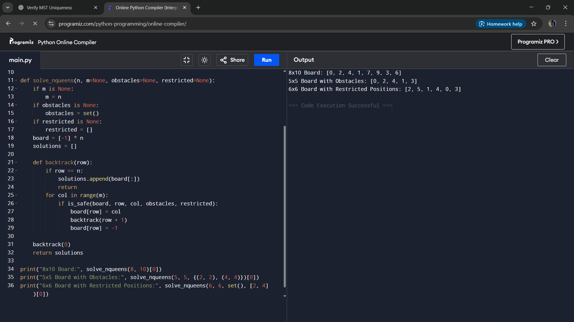

**Result**  
The generalized N-Queens algorithm was successfully applied to different board configurations. The algorithm handled rectangular boards, obstacle placements, and restricted positions while ensuring valid solutions.

**Performance Analysis**

* Time Complexity: O(N!) in the worst case due to backtracking.
* Space Complexity: O(N) for storing queen positions and recursion stack.